DOCKER QUESTIONS AND ANSWERS

- What is Docker file?
Ans-A Dockerfile is a text file that contains instructions for creating a container image. The Docker engine uses these instructions to build the image.
Dockerfile contain:
Base image: The image to use as a base for the new container image
Commands: Commands to run during the image creation process
Startup command: The command to run when the container image is deployed
Files to copy: Files to copy into the container image
Working directory: The directory to use for certain instructions
Default program: The program to run when the container starts
How do I use a Dockerfile?
Create a Dockerfile
Use the docker build command to process the Dockerfile and create the image
What are some common Dockerfile instructions?
FROM: Defines the base image
RUN: Executes commands in a new layer on top of the current image
WORKDIR: Sets the working directory for subsequent instructions
COPY: Copies files or directories into the container image
CMD: Defines the default program to run when the container starts
SHELL: Overrides the default shell used for commands

- what is Docker Image?
Ans- A Docker image is a file that contains the instructions and files needed to create a Docker container. Docker images are used to package applications and preconfigured server environments.
What's in a Docker image?
- Application code: The code that makes up the application
- Libraries: The libraries required for the application to run
- Dependencies: The other programs and resources the application needs to run
- Tools: The tools needed for the application to run
How are Docker images used?
- Create containers
A Docker image is used to create a container, which is a virtualized runtime environment for running an application
- Share images
Docker images can be shared with other Docker users or deployed in multiple locations
- Store images
Images can be stored in registries to keep track of projects, business segments, and user group access
How are Docker images structured?
- Docker images are made up of multiple layers, each adding something to the environment
- The layers are read-only, but a writable layer is added on top of the image when a container is created
- What is docker container?
Ans- A Docker container is a package of software that includes everything needed to run an application. Containers are created using the Docker open-source container runtime.
What's in a Docker container?
- Code: The application code
- Dependencies: The libraries and other files needed to run the application
- System tools: The tools needed to run the application
- Runtime: The environment that runs the application
How do Docker containers work?
- Docker containers run on a server, machine, or cloud instance
- Containers share the machine's operating system (OS) kernel, so they don't need their own OS
- Containers are lightweight, portable, and can run on Linux or Windows
What are the benefits of Docker containers?
- Containers are secure
- Containers allow developers to quickly build, test, and deploy applications
- Containers allow developers to easily share their work with colleagues
- Containers allow developers to fix bugs and redeploy them to test and production environments
How do you create a Docker container?
- Create a Dockerfile, which is a text file that contains instructions for creating an image
- Use the Dockerfile to create an image
- Use the image to create a container
- What is containarisation?
Ans- Containerization in Docker is the process of packaging an application and its dependencies into a container. Docker is a platform that allows developers to build, ship, and run these containers.
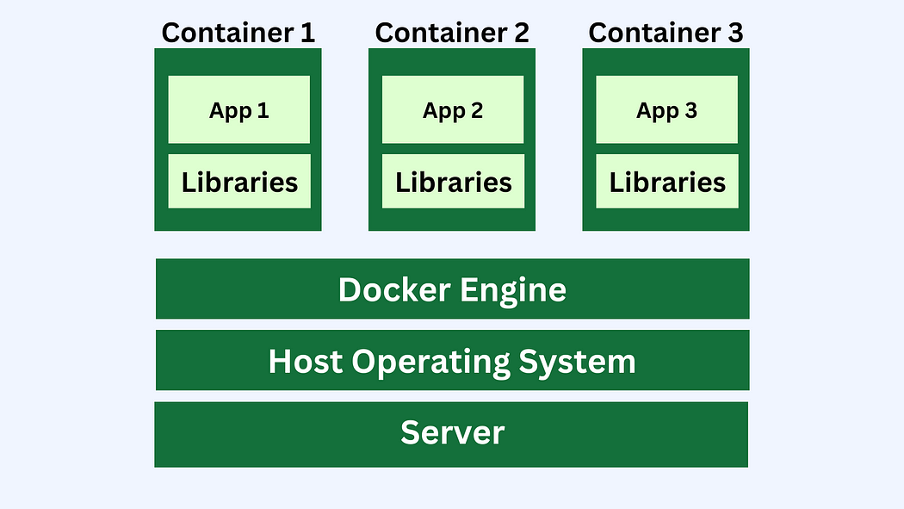

How does it work?
- Docker images: These are read-only templates that define what's inside a container. They are created using a Dockerfile, which is a text file that specifies the environment and steps for building the image.
- Docker containers: These are runtime instances of Docker images. They contain everything an application needs to run, including code, libraries, and configuration files.
- Docker Hub: This is Docker's cloud repository, where users can store and share images.
Benefits of containerization
- Faster development: Developers can focus on writing code without worrying about the infrastructure.
- More efficient: Containers are more portable and resource-efficient than virtual machines (VMs).
- More secure: Containers are isolated from other software and hardware objects.
- Consistent performance: Containers ensure consistent performance across different settings.
Containerization is a key part of Platform as a Service (PaaS), which is a cloud computing model that allows developers to build, test, and deploy applications.

- Explain the working of Docker.- written in notes so use that to write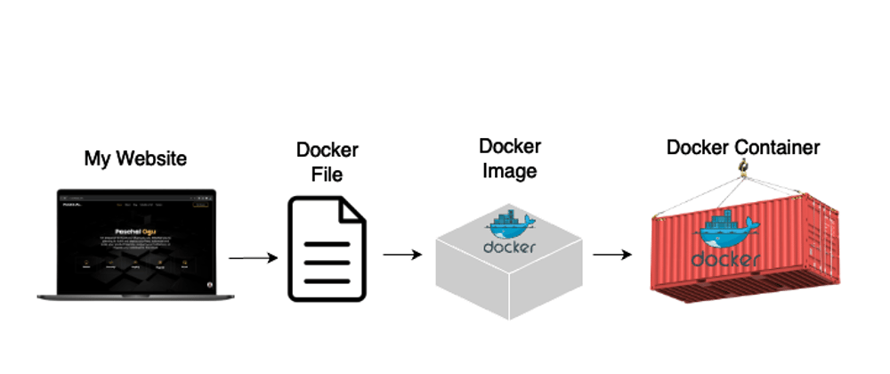
Docker is a computer program that performs operating system level virtualization. It was introduced by Solomon hykes in 2013.
The Docker working is shown as above image. It contains Docker file docker image and docker container.
In docker file It contains all the configuration files to create an image, once it is runs on your docker, so it forms the docker image. So the Docker image once runs it forms the Docker container. So the container is to carry the dat from one to another(it is the storage of all data)

- Difference Between Vertualisation and containarisation.
Ans- Virtualization and containerization are both technologies that help make applications independent from the underlying hardware. Virtualization uses virtual machines (VMs) to create isolated environments, while containerization uses software packages called containers to bundle applications.
 | Virtualization | Containerization
- What it does  - How it works  - When to use it  - Benefits | Creates VMs that run their own operating systems and use dedicated hardware resources.  Uses a system plan to create logical partitions and assign resources to them  When you need to run an application on a specific hardware platform or when you have specific hardware requirements  Provides strong isolation between VMs, which can improve security and prevent applications from interfering with each other | Bundles an application's code, libraries, and other dependencies into a container  Uses the host operating system's kernel and shares hardware resources among containers  When you want to scale applications quickly and efficiently, or when you want to minimize the number of servers you're using  Makes applications portable so they can run on any device, and is ideal for microservices architecture

- What is Docker?
Ans-Docker is a software platform that allows you to build, test, and deploy applications quickly. Or
Docker is a platform that provides a service that enables a single host system to run more than one container.
- What are /bin /lib files?
Ans- Bins and Libs are binaries and libraries files required to run the applications. But they are not similar to VMs. here, Binaries and Libraries files are built as packages by the docker known as Docker image

Docker works by packaging applications and their dependencies into self-contained units called "containers" using a layered image system, allowing developers to run applications in isolated environments across different systems with consistent behavior, essentially creating a standardized way to deploy applications by leveraging the Linux kernel features like namespaces and cgroups to isolate processes and resources within each container, making them portable and efficient; this is managed through a client-server architecture where the Docker client interacts with the Docker daemon to build, manage, and run containers based on instructions defined in a Dockerfile.
Key points about Docker:
- Images:
A Docker image acts as a blueprint for a container, defining the application's file system and configuration, built using a Dockerfile which contains instructions for creating the image layer by layer.
- Containers:
When you run a Docker image, it creates a container, which is a running instance of that image with its own isolated environment including file system, network, and process space.
- Isolation:
Containers are isolated from each other and the host machine, meaning changes made within a container do not affect other containers or the underlying system.
- Portability:
Because Docker containers are self-contained, they can run consistently across different environments, like development machines, testing servers, and production servers, without requiring specific configurations on each host.
How Docker works:
- Dockerfile:
Developers write a Dockerfile which specifies the steps needed to build a Docker image, including installing packages, copying files, and setting environment variables.
- Building an Image:
The Docker daemon reads the Dockerfile and executes the instructions to create a layered image, where each layer represents a specific change made during the build process.
- Running a Container:
When you run a Docker command like docker run, the Docker daemon creates a new container based on the specified image and starts it.
- Client-Server Architecture:
Docker uses a client-server architecture where the Docker client communicates with the Docker daemon (running on the host machine) via a REST API to manage containers and images.
Benefits of Docker:
- Application consistency:
Ensures applications run the same way across different environments.
- Development workflow efficiency:
Streamlines development by isolating application dependencies and simplifying deployment.
- Scalability:
Enables easy scaling of applications by creating multiple container instances.
- Resource optimization:
Containers are lightweight compared to virtual machines, allowing for better resource utilization.
Docker is an operating system that allows developers to package, run, and manage applications in containers. Docker uses a client-server architecture to build, run, and distribute containers.
How Docker works
- Package: Developers use Docker to package their applications into containers. These containers include all the necessary files, libraries, and dependencies to run the application.
- Build: Developers use Docker to build the containers.
- Run: Developers use Docker to run the containers on a host.
- Monitor: Developers use Docker to monitor the containers and correct bugs.
- Test: Developers use Docker to run automated and manual tests on the containers.
- Deploy: Developers use Docker to deploy the containers into production.
How Docker differs from virtual machines
- Docker containers virtualize the operating system of a server, while virtual machines (VMs) encapsulate an entire OS.
- Docker uses resource isolation in the OS kernel to run multiple containers on the same OS.
- Docker containers are portable and can run consistently across different environments.
How Docker uses cgroups and namespaces
- cgroups
Control groups that manage and monitor resource allocation for a container.
- Namespaces
Isolate process groups from each other. Each container has its own namespace.
Containerization in Docker is the process of packaging an application and its dependencies into a container. Docker is a platform that allows developers to build, ship, and run these containers.
How does it work?
- Docker images: These are read-only templates that define what's inside a container. They are created using a Dockerfile, which is a text file that specifies the environment and steps for building the image.
- Docker containers: These are runtime instances of Docker images. They contain everything an application needs to run, including code, libraries, and configuration files.
- Docker Hub: This is Docker's cloud repository, where users can store and share images.
Benefits of containerization
- Faster development: Developers can focus on writing code without worrying about the infrastructure.
- More efficient: Containers are more portable and resource-efficient than virtual machines (VMs).
- More secure: Containers are isolated from other software and hardware objects.
- Consistent performance: Containers ensure consistent performance across different settings.
Containerization is a key part of Platform as a Service (PaaS), which is a cloud computing model that allows developers to build, test, and deploy applications.

Single sign-on (SSO) is a user authentication method that lets users log in to multiple applications using one set of credentials. SSO improves security and user experience by eliminating the need to log in to each application separately.
How SSO works
- The user logs in to an application
- The application verifies the user's identity
- The application issues an SSO token
- The token is stored in the user's browser or another secure location
- When the user tries to access another application, the token is sent to that application
- The application verifies the token and grants access to the user
SSO use cases
- Company intranets and extranets
- Student portals
- Public cloud services
- Customer-facing websites and apps, such as banking and e-commerce
SSO benefits Simplifies the authentication process, Improves user experience, Improves security, and Eases the management of multiple usernames and passwords.
Working of docker
A Docker Engine operates as a client-server system where the "Docker client" (command-line interface) sends instructions to the "Docker daemon" (the core engine) which then manages the creation, running, and distribution of containerized applications by utilizing Docker images stored in registries like Docker Hub; essentially, it allows users to build and run isolated application environments on their system through a series of commands issued via the client.
Key components of Docker Engine:
- Docker Client:
The user interface that interacts with the Docker daemon using commands like "docker run" or "docker build" to manage containers.
- Docker Daemon (Engine):
The core process running on the host machine that handles the actual work of creating, managing, and running containers based on instructions from the client.
- Docker Images:
Read-only templates that define the application environment and are used to create containers.
- Docker Registry:
A repository where Docker images are stored and can be accessed by users to pull or push images.
How it works:
- 1. Building an Image:
  - User writes a Dockerfile, which is a script defining the steps to create an image.
  - The Docker client sends the Dockerfile to the Docker daemon.
  - The daemon executes the Dockerfile instructions, layering the necessary files and configurations into a new Docker image.
- 2. Running a Container:
  - User uses the docker run command with the desired image name.
  - The Docker client sends the request to the daemon.
  - The daemon pulls the image from the registry if needed.
  - The daemon creates a new container by allocating resources and creating a file system based on the image.
  - The container starts running the application defined in the image.
Key points about Docker Engine:
- Isolation:
Each container is isolated from other containers and the host system, ensuring that applications run in their own environment.
- Lightweight:
Containers share the host kernel and only need to copy necessary application files, making them lightweight.
- Portability:
Docker images can be easily shared and run on different systems with compatible Docker engines.

